**Rock, Paper, Scissors**

**1. Introduction**

* This program is based on the classic children’s game: Rock, Paper, Scissors. It is a simple game where one chooses one of the titled options against another player – which then results in a win, loss, or a draw. Fans of the Big Bang Theory are also familiar with the modification the character Sheldon gave to the classic game: adding the options of Lizard and Spock. The program gives the user options to play the classic 3 option or the one Sheldon invented. Users can also pick to play against a robot or another user.

**2. Design and Implementation**

* The program was basically just designed to be a console version of the classic game. A user or users are told to pick between Rock, Paper or Scissors (or Lizard or Spock), and then when the users make the pick, a message pops up on who wins, who loses, and who draws. One made up the pseudocode for the program in the previous couple of weeks activities and one mostly followed that.
* Some screenshots of gameplay:

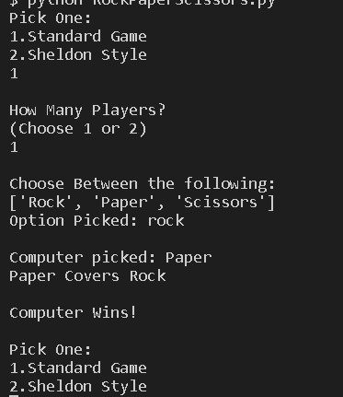 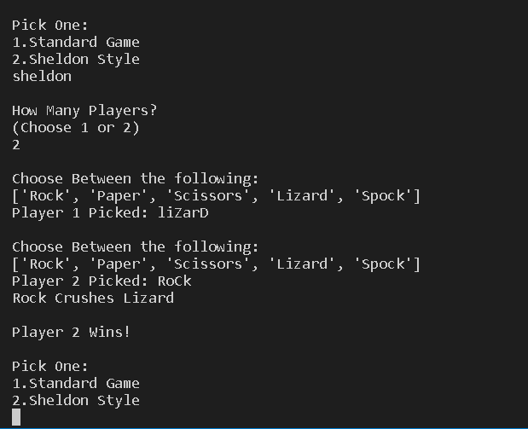

**3. Conclusions**

* As I was already quite familiar with Python doing this course, I mostly used this project to sharpen my skills. I did learn things like how one should either capitalize/lowercase all comparisons to make capitalization not be a factor in a capitalization, or how datatypes must be consistent and this can be a bit different in Python as one cant just write String value1 or int Value2 as is the case with C/C++/C#/Java but rather assume conditions and treat it as such, and to convert values to the proper datatype when this is not as clear.
* This project does implement Rock, Paper, Scissors quite well.
* One believes that the program could have been better by better use of DRY (Don’t Repeat Yourself), being more modulated, and having more ways to select options such as factoring typos.
* Additional features that may be cool to add in the future may be turning the console game into a Graphic User Interface, having a feature that lets users play against each other remotely, and adding other alternative versions of the game such as the one Mithrandir.com came up with where Match and Phoenix is added into the game.
* An exit feature ought to be added in updates